

Project Report

Event Sphere

CONTENTS

1. Background and need for the portal
2. Proposed Solution
3. Purpose Of the Document
4. Who can use this Document?
5. Scope Of Project
6. Constraints
7. Functional Requirements
8. Non-Functional Requirements

­­

**Team Members**

**SFC-CODE AVENGERS**

|  |
| --- |
| M.Taqi Adeem |
| Syed Mehdi |
| M.Faiez |
| Raheel |

# 1. Background and need for the portal

E

ducation is a primary necessity and for parents/guardians to be updated about their wards, progress is even more important. Students who fail in exam might not reveal their marks to their parents/guardians because of fear. Teachers too are overloaded with work, because of which it becomes difficult to remember each child’s academic progress. Also, students too must be kept aware about their score

Progress and marks required for passing external exams. A web portal to track all these is a solution. Given below is an example of it:

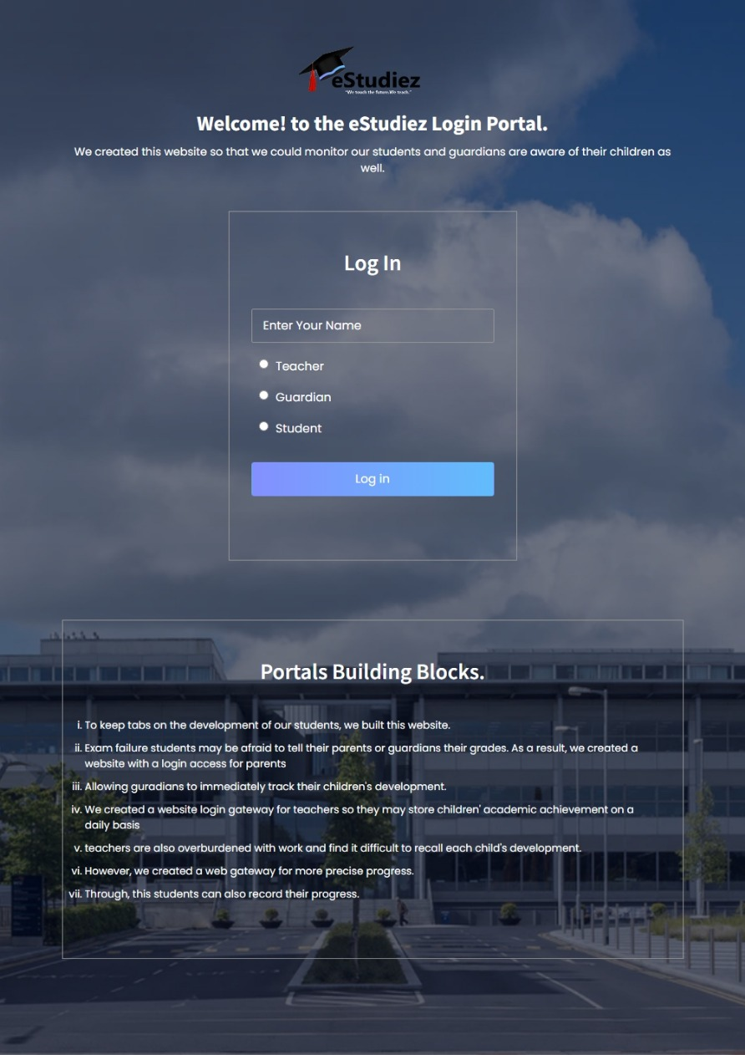

# 2. Proposed Solution

T

he website is design and built named “eStudiez” which is intended to track academic progress of a student this system allows various types of users like student, teachers and parents/guardians to view and track progress

Students who have fared poorly will be provided additional study resources via through this portal to improve their future performances. This portal will also provide information regarding revision classes that can help to boost performance and improve their results.

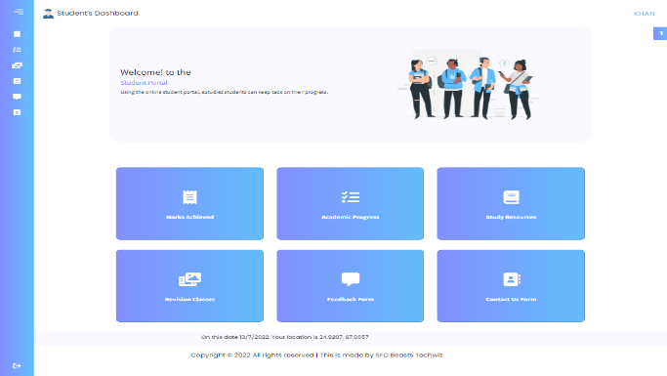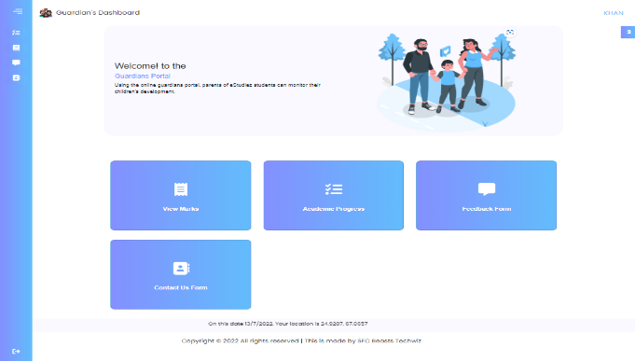 Each student’s progress can be viewed and tracked by students themselves and their parents/guardians.

**STUDENTS DASHBOARD**  **PARENTS/GUARDIAN DASHBOARD**

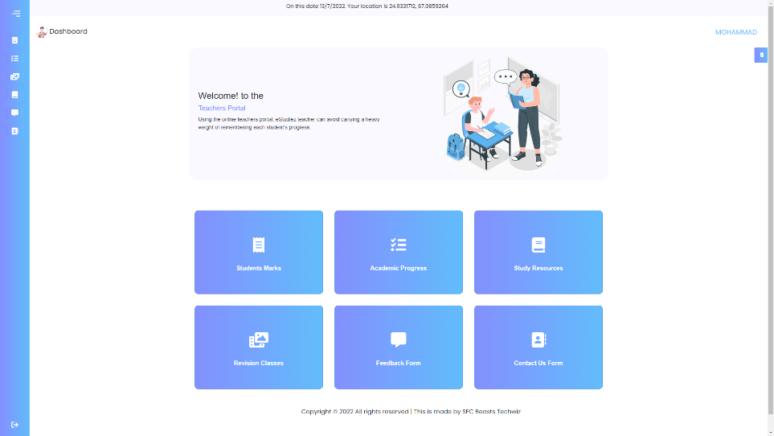

**TEACHERS DASHBOARD**

# 3. Purpose of the Document

eStudiez portal is purposed as an online support portal for users (Students/Teachers/Parents/Guardian)

This Document:

* ***Presents purpose and features of the portal.***
* ***Explains interfaces of the portal.***
* ***Describes what the portal will do.***
* ***Lists the constraints under which it must operate***



# 4. Who can use this Document?

* Stakeholders of the portal
* Developers of the portal

# 4. Scope of Project

I

t provides an engaging student experience with a single point of access and hub to all applications, information, and content. One of the biggest obstacles that a student portal removes is the number of information silos found across colleges and universities today. The web portal will be a responsive and visually appealing website to be used by individuals (Students/Teachers/Parents/Guardians.)

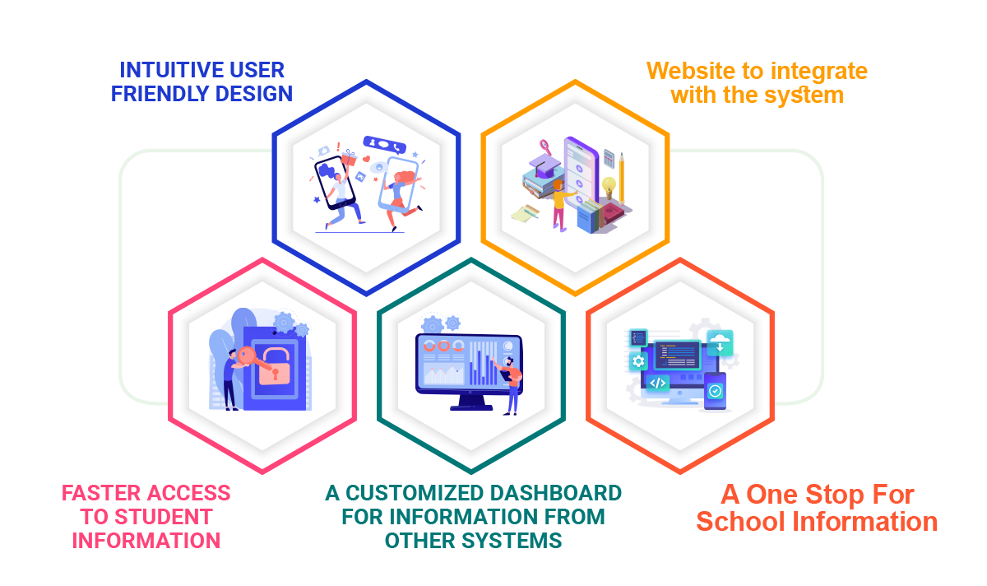

# 6. Constraints

C

onstraints also known as a limitation or restriction. The Web Portal will not have any facility to store information on the server. Information can be fetched from pre-populated JSON or TXT files and displayed; however, information cannot be written to the files from within the portal.

­­­­­­­

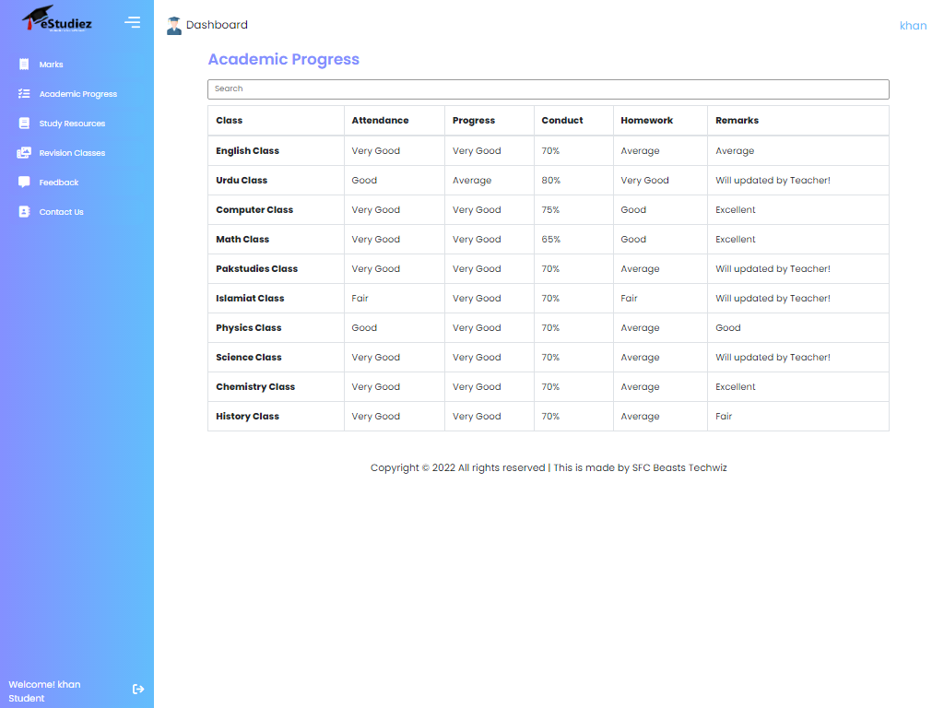

# 7. Functional Requirements

The portal is designed as a Single-Page-Application and responsive Website with a set of pages and menus that represent choice of activities to be performed. The pages, menus, and other visual elements are designed in a visually appealing manner with attractive fonts, colors, and animations. All of these are laid out in a responsive manner.

* **Menus and Web Page Functionality:**
* **Welcome Message:**

The home page accepts first name from the user and displays a personalized name. At the top corner, the user's first name is displayed for the entire duration that the portal is loaded. The login page also accepts category of user in the form of radio button selection. Based on selection, respective page and menus will be displayed. Refer the Sitemap section to see sample menus.

* **For Students:**

Marks that they have scored in internal tests conducted by teachers are displayed in a table. Academic Progress menu option displays the gradual progress in various tests across the year in the form of table data. Study Resources menu option displays a table containing links to Videos, and additional textbooks. Revision Classes menu option contains display information pertaining to extra classes for revision purposes. Date and time of classes are displayed there. Contact us page will display list of phone numbers that students can call in case they require general assistance.

* **For Teachers:**

Teachers can update marks that students have scored in internal tests conducted. This is done through a form. These marks are not stored anywhere and will not reflect on the student page as that functionality is beyond the scope. Academic Progress menu option will enable teachers to update the gradual progress in various tests across the year. The data for this is accepted via form. Add Study Resources menu option is enabled teachers to add links to external sites, and additional textbooks. Revision Classes Updating accepts date and times for extra classes for revision purposes.

* **For Parents/Guardians:**

They can view marks and academic progress of their wards. Helplines will display list of phone numbers that parents/guardians can call in case they require general assistance.

* **Feedback and Contact Us**

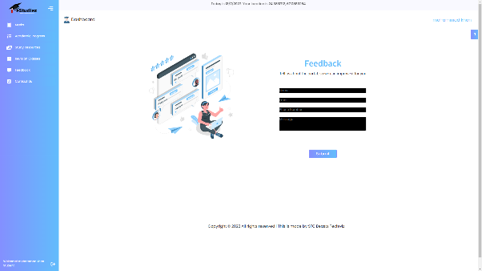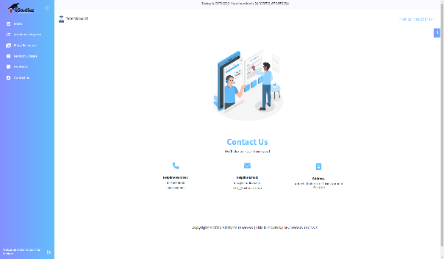These menu options have common functionality for all category of users regardless of whether they are students, teachers, or parents/guardians. Feedback menu option should enable users to provide their feedback about this portal through a feedback form. Contact Us menu option should enable users to contact the creators of the portal. An email id can be displayed here for contact information. Over and above this, the portal should implement following functionalities:

* Display a continuous scrolling ticker at the bottom of the page with current date, time, and location (hint: Use geolocation features of HTML5).
* Display a visitor count at the top right corner of the page beside a logo image.
* Menu options should change color on hover and also after clicking.
* Fade-in and fade-out options can be used for the menus.

# 8.Non-Functional Requirements

There are several non-functional requirements that should be fulfilled by the Website, henceforth called the 'system'. *The system should be*:

* **Safe to use:**

The system does not result in any malicious downloads or unnecessary file downloads.

* **Accessible:**

The system is clear and legible fonts, user-interface elements, and navigation elements.

* **User-friendly:**

The system is easy to navigate with clear menus and other elements and easy to understand.

* **Operability:**

The system operates in a reliably efficient manner.

* **Performance:**

The system demonstrates high value of performance through speed and throughput. In simple terms, the system is fast to load and page redirection is smooth.

* **Capacity:**

The system supports large number of users.

* **Availability:**

The system is available 24/7 with minimum down time.

* **Compatibility:**

The system is compatible with latest browsers